CENWP-OD-B 21 January 2025

MEMORANDUM FOR THE RECORD

SUBJECT: 25BON001 MFR Oil Spill in PH1 Forebay

On Thursday 16 January 2025 at 0845, the Powerhouse 1 (PH1) mechanical crew notified the Bonneville Environmental Compliance Crew (ECC) and the spill response team of the possible presence of an oil sheen in front of Ice and Trash Sluiceway (ITS) 10B gate slot in the PH1 forebay. The ECC and spill response team arrived on scene at 0900 and confirmed multiple 3-inch globular, milky, white, oily substances had surfaced during routine trash raking operations at gate slot 10B. An oil boom was deployed and the substance was recovered. The source of the sheen was unknown at the time, and USACE is not suspected to be the source due to the absence of any filled equipment being located upstream of the gate slots. At the time, the volume of oil was estimated to be around 1 tablespoon, and crews suspected the source to be contained within the debris that was dislodged from the gate slot during trash raking operations.

At 1140 on 16 January, the mechanical crew contacted ECC to return to gate slot 10B due to the presence of a larger oil sheen after what appeared to be a large canvas agricultural tote was snagged and partially lifted with a clamshell claw attachment on the crane. The tote partially surfaced, and a rainbow sheen formed around the tote before the tote broke off and resubmerged. Based on this evidence, the tote is suspected to be the source of the oily substance; however, the tote could not be recovered after it sank below the water surface. When the tote broke off from the crane attachment, the crane’s wire rigging became twisted and an all stop to current operations was issued due to concerns of significant damage to the sole forebay gantry crane as well as safety concerns for the personnel. Thus, this operation was ceased, and the decision was made by Bonneville Project to declare an emergency to receive an emergency contract to salvage this tote.

A Caution Order was placed on the gate for slot 10B with instructions to not operate this gate until Operations has been given permission to do so.

On Friday 17 January 2025 at 1230, Portland District Dive Team, Bonneville Mechanical Crew, ECC, and Oregon DEQ Emergency Response Planner began a coordinated effort to retrieve the object. An oil boom was deployed to capture any potential loss. Dive operations were able to locate the object, which turned out to be an agricultural super sack. The divers rigged the super sack to raise via PH1 gantry crane and the object was retrieved. During rigging operations, sporadic micro sheens were observed resulting in an estimated 1 Tbs oil substance to surface water. No material remained in the super sack upon recovery and no identifying labeling was present to determine source, however it has been confirmed to not be property of USACE.

Due to the location of dive operations, the PH1 ITS was closed from 1030 to 1500. This closure remained within the 6 HR allowable ITS closure per day found in the 2024 FPP Section BON 2.4.1.12. After dive operations completed and the clearance was lifted at 1500, the ITS returned to normal operation.

- Species – NA
- Origin – NA
- Length – NA
- Marks and tags – NA
- Marks and Injuries found on carcass – NA
- Cause and Time of Death – No mortalities.
- Future and Preventative Measures – NA
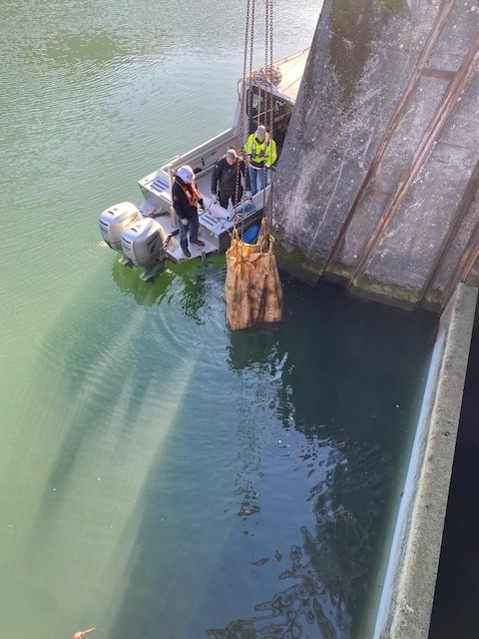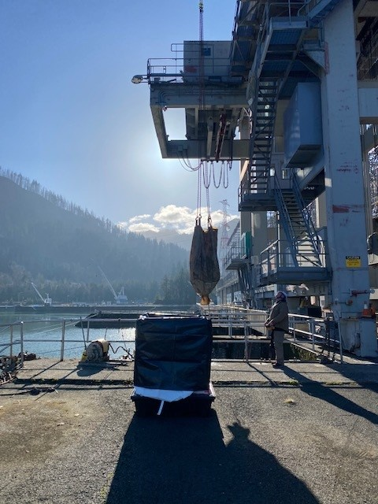

Sincerely,
Bonneville Project Fisheries

